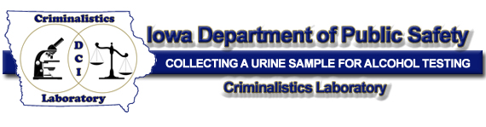

I, _____________________ (typed name) of the ________________________ (Department)
have viewed and understand the “Collecting a Urine Sample for Alcohol Testing Version 1.0” training video on the Crime Laboratory website.
Date:_______________________

