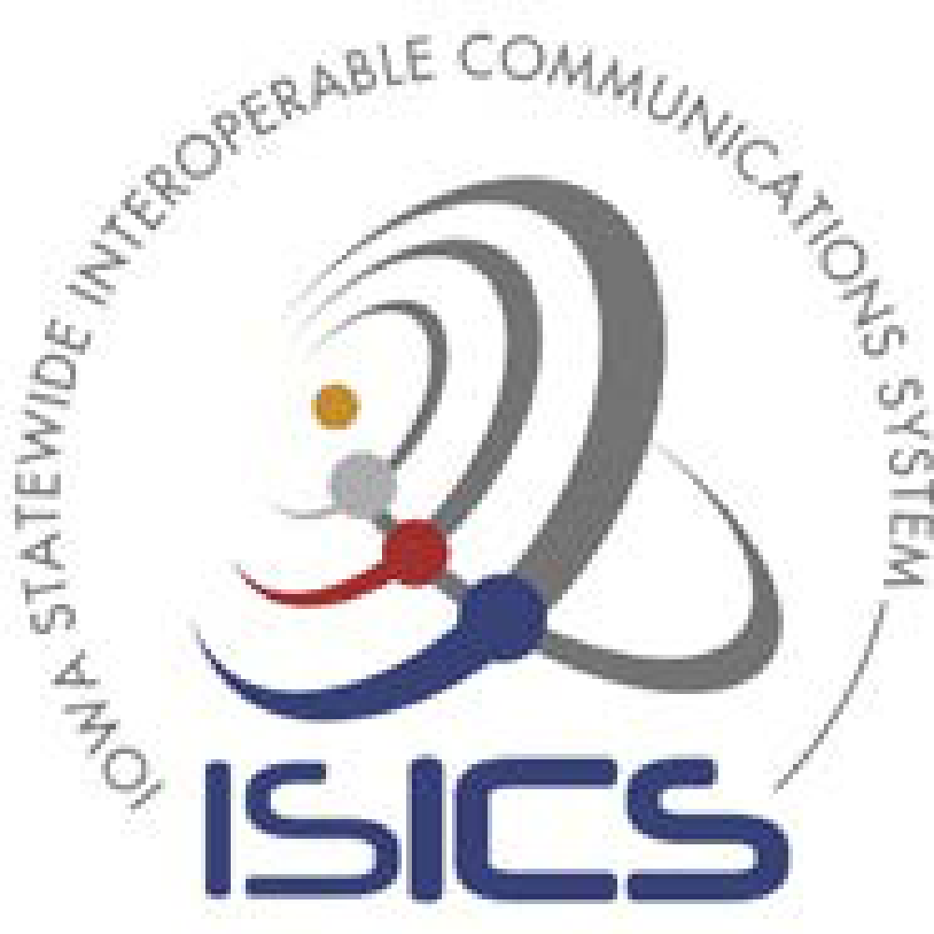

Iowa Statewide Interoperable Communications System (ISICS)
Standards, Protocols, Procedures

ISICS Standard:  Medical Interoperable Communications | Standard #:
ISICS Standard:  Medical Interoperable Communications | Date Adopted:
ISICS Standard:  Medical Interoperable Communications | Date Reviewed:
ISICS Standard:  Medical Interoperable Communications | Version: | 1.0

1. Purpose or Objective
The purpose of this standard is to establish the operational use of the ISICS statewide and regional interoperability talkgroups for establishing and maintaining medical communications as provided in the appended list IAMEDSWE, R1MED10E, R2MED20E, R3MED30E, R4MED40E, R5MED50E, R6MED60E, SR1MED110E. These talkgroups are shared resources that allow interoperability between emergency medical services personnel for the purpose of saving lives.

2. Technical Background
- Capabilities
The Iowa Statewide Interoperable Communications System Board (ISICSB) has established a standard for use of the ISICS statewide and regional interoperability talkgroups in ISICS Standard 1.5.0. This standard encourages interoperable communications among first responders and establishes common ISICS statewide and regional interoperability talkgroups to facilitate interoperability.
As provided in the geographically appropriate appended State/Regional Call Talkgroup list in this Standard, ISICS users in the medical discipline have talkgroups dedicated to interoperable communications.
- Constraints
Experience has shown that communications between responders in the field and communications in a hospital setting can vary greatly. Over the last number of decades cell phone use has become more common for standardized communications in some settings. Cell phone communication is not mission-critical public safety grade infrastructure. Through best practices, this standard strives for consistency among agencies that utilize ISICS. The availability of, and the use of the regional and statewide interoperability talkgroups must be easily understood by radio user personnel who are primarily concerned with their mission and not with the operation of complex radios under stressful conditions. Standardization of capabilities will provide responding agencies with an assurance that they will have interoperable communications with any other agency with whom they need to communicate.
3. Operational Context
Emergency medical services personnel and others in public safety may need to coordinate operations and resources with hospitals locally or across a large multi-jurisdictional area of the state. This standard works to facilitate successful interoperable medical communications for scalable events. The layout of the talkgroup for each region of the state allows that, no matter where a responder might travel, they should be able to communicate with any treating facility who, through this Standard, is recommended to always be monitoring their regionally appropriate talkgroup for their geographic location.
The ISICS user understands they must be aware of and comply with all rules, regulations, policies, procedures, protocols, guidelines, standards, or requirements as established by the ISICSB, related to the use of ISICS.
4. Recommended Protocol/Standard
Hospitals should always monitor the MED talkgroup respective to their geographical region for situational awareness, to be aware of incoming patient reports, mass casualty incidents (MCI), and other incidents that could potentially influence their operational readiness.
Public safety field units should have radios programmed with the available MED talkgroup for the purpose of communications with hospital personnel for delivering patient reports, other field to hospital information, and receiving orders.

These are state and regional talkgroups available to any agencies in the geographic locations, so it will be possible and probable that more than one incident may be occurring at the same or similar times, ensure that you wait for a clear talkgroup before keying up your radio.

5. Recommended Procedure
- Monitor the geographically appropriate regional or statewide medical talkgroup listed in the appended State/Regional Call Talkgroup list.
- EMS with a need to contact a hospital would navigate to the geographically appropriate regional or statewide MED talkgroup listed in the appended State/Regional talkgroup list.
- Before keying the microphone, listen for a clear talkgroup – ensure no other traffic is occurring before you call out.
- It is very important to be clear in who you are and who you are trying to reach.
- Wait for the permit tone before speaking. The calling entity hails or states who they are calling and then identifies themselves.
  - Example:, a Carroll County Ambulance is enroute to Iowa Methodist Medical Center in Des Moines with a transfer and they do not have Iowa Methodist’s operational talkgroups programmed in their radios. Carroll County Ambulance may call on the geographically appropriate regional Medical talkgroup listed in the appended State/Regional Call Talkgroup list by calling out or “hailing” as described below:

“Des Moines Methodist from Carroll County ambulance 14-33 on R1MED10E”

Des Moines Methodist – hearing their name over the talkgroup would call back:

“Carroll County 14-33, go ahead for Methodist on R1MED10E”

Carroll County may then proceed with any pertinent information for Des Moines Methodist on R1MED10E. There may be a number of back and forth communications between the two entities from here on out and it would be proper at this point to drop the name of the talkgroup off and shorten the name of the ambulance or hospital. Any extended pause in communication would require that the communication be re-established.
Encryption

The talkgroups referenced in this Standard and listed in the appended list are encrypted talkgroups. When necessary, emergency response personnel require that information is encrypted so that security can be maintained. ISICSB policy does support encryption on specific interoperability channels and talkgroups. For Encryption, see ISICS Standard 2.12.3 Encryption Key Security.
6. Management
Nothing in this standard shall be construed as a limitation of use of the ISICS statewide and regional interoperability talkgroups for incidents requiring interoperability.
For Management, see ISICS Standard 1.5.0 ISICS Regional & Statewide Interoperability Talkgroups for additional information.

Appended List of Talkgroups for Medical Interoperable Communications
Statewide | Region 1 | Region 2 | Region 3 | Region 4 | Region 5 | Region 6 | Sub-Region 1
IAMEDSWE | R1MED10E | R2MED20E | R3MED30E | R4MED40E | R5MED50E | R6MED60E | SR1MED110E

