
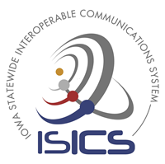
Radio Affiliation and Scanning
Whitepaper

ISICSB Training & Outreach Committee
May 2024

Iowa Statewide Interoperable Communications System
isicsb.iowa.gov


Radio Affiliation and Scanning

Contents Abstract
This whitepaper will discuss the process of talkgroup scanning on your radio while using the Iowa Statewide Interoperable Communica- tions System (ISICS). It is important to know how tower site affiliation conjointly works with scanning to operate efficiently on the system.
Abstract 2

Introduction 3

Radio Affiliation 4

Scanning 6

Conclusion 8

Radio Affiliation and Scanning

Introduction

Affiliation is the process of a radio connecting to and interacting with a trunking system site. When a radio is powered on or off or the channel is changed, affiliation data is exchanged, informing the site of the radio’s status and current selected channel. Affiliation allows the radio tower site to see if a radio is active on the system, permitting the trunked radio system to send voice and data information to the receiving radios.

All radio tower sites have a site controller. The site controller is responsible for handling all control channel traffic, including affiliation, call requests, patches, etc. The control channel is broadcast continuously on each site. When a radio is turned on, it searches for the strongest control channel belonging to the system and then attempts to affiliate with that site. The radio identifies itself to the site using its unique radio ID, which is a set of numbers that identifies that specific radio on the system. If the tower site recognizes the radio ID as valid on the system, it will then grant access to the system.

After the radio is granted permission to join the radio site, the radio sends another request for permission to join the selected channel the radio is on. Once the tower site recognizes the radio ID that is allowed on that site, it is permitted to participate on that talkgroup. The user may use the radio to make calls to other users affiliated on the selected talkgroup. All the affiliation and data processing occurs simultaneously within milliseconds of being turned on, which is not usually noticed by the radio user.

When a user changes the channel in their radio, the radio sends a de-affiliation message, indicating its departure from the channel. When the user selects the new talkgroup they want to operate on, a new message is sent to the tower site requesting another affiliation to the new channel. The controller must then verify if that radio has permission to utilize that channel. When the user powers off their radio, the radio sends a message for total de-affiliation to the site letting the system know that radio is powered off.

Affiliation becomes important when discussing scanning channels on your portable and mobile radios. Below are visuals of a portable radio during affiliation.

Radio Affiliation and Scanning
Radio Affiliation

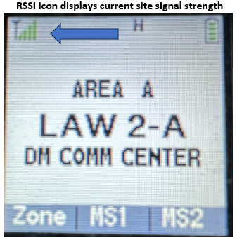

- Radio is powered on. The radio
will locate the best tower site to use. The green signal indicator is showing ful. The icon is called the RSSI meter (received signal strength indicator).

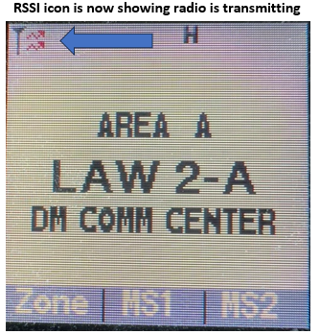

- Radio is transmitting data initiating a radio affiliation request with the site control channel to request access to the site.

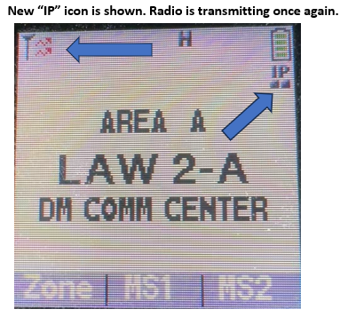
Radio Affiliation and Scanning

3) The radio is now showing a new icon on the screen “IP”. Now the tower site has granted affiliation on the site and data services are enabled. The radio is now sending an affiliation request to join talkgroup “Law 2-A”.

3)

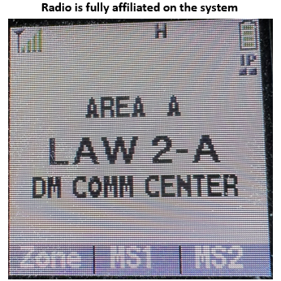

4) The radio is now fully affiliated and can now transmit and receive data and voice. The whole process took less than a second to complete without any notice to the user.

Radio Affiliation and Scanning
Scanning
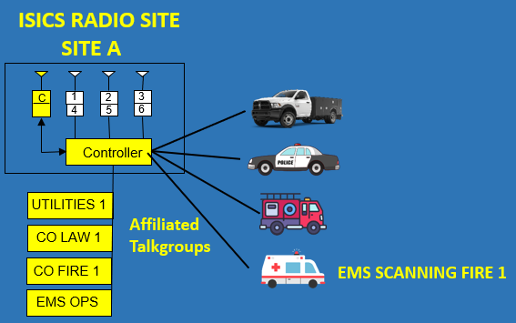

Scanning on a trunked radio system is much different than scanning on a conventional radio system. The trunked system strives to be efficient with all system resources. Channel efficiency means talkgroup audio is broadcast on tower sites where a radio is registered.
In this example we have 4 different users affiliated to ‘site A’. Even though no channels are currently being used, the control channel still acknowledges the 4 channels are there and available. The ambulance’s mobile radio is selected on channel ‘EMS OPS’ and they are scanning channel ‘CO FIRE 1’.

Radio Affiliation and Scanning
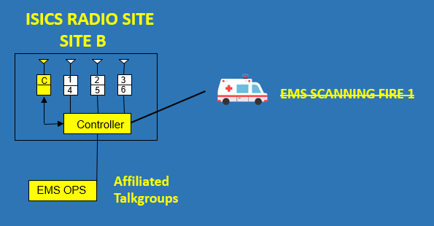

The ambulance has now traveled outside of coverage for ‘site A’ and has now affiliated to ‘site B’. They will not be able to scan channel ‘CO FIRE 1’ because no other user on that talkgroup is affiliated to ‘site B’. If a talk group is not “needed” on a site, then it won’t be available to scan.

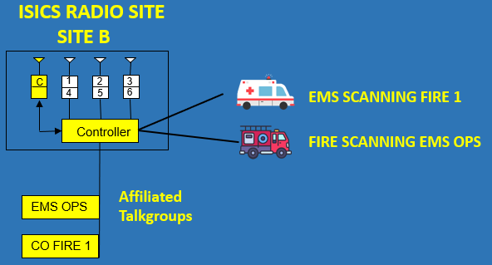

The fire engine has also now affiliated to ‘site B’. Channel ‘CO FIRE 1’ has been
affiliated to this site. Now, the ambulance and fire engine can scan each other’s
talkgroups.
Radio Affiliation and Scanning

Conclusion
Understanding the intricacies of radio affiliation and scanning within trunked systems is crucial for efficient communication and resource utilization. Affiliation serves as the gateway for radios to connect with tower sites, enabling seamless transmission of voice and data information. Whether it's changing channels, or initiating scanning, each action triggers an affiliation process that ensure radios are linked to the appropriate sites and talkgroups. This seamless exchange of affiliation data, facilitated by the site controller, underscores the system's ability to optimize channel efficiency and ensure that users can communicate effectively across different sites and talkgroups, ultimately enhancing operational effectiveness and response coordination in critical scenarios.

