
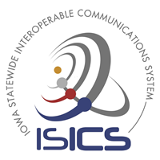
Two-Way Communication Patching
Whitepaper

ISICSB Training & Outreach Committee
May 2024

Iowa Statewide Interoperable Communications System
isicsb.iowa.gov


Two-Way Communication Patching

Contents Abstract
This whitepaper will discuss the process of two-way communications patching. On the Iowa Statewide Interoperable Communications System (ISICS), patches enhance communications capabilities and introduce unique limitations to consider for critical situations.
Abstract 2

Introduction 3

Types of Patches 3

Soft Patches 3

Hard Patches 4

Patching 5

Resource Management with Patching 5

Resources and StatusBoard 5

Announcement of a Patch 5

Patching with Encryption 5

Local Policy and Procedure 5

Conclusion 5

Two-Way Communication Patching
Two-Way Communication Patching

Introduction

What is a Patch?

A patch is a group of one or more “linked” or “grouped” channels that allows radio users to communicate with each other while on separate radio channels, talkgroups, and/or radio systems. While the patch is active, all channels will act as one. Regardless of the channel/talkgroup the user transmits from, the transmission will broadcast over the other channels/talkgroups of the patch as well.

A communications patch is vital tool in ensuring effective radio communication between different users, agencies, and different radio systems, there are also limitations and considerations when it comes to patching. A patch allows users to bridge a gap between various radio networks, even if the other networks are using different protocols and technologies. Patches have been proven beneficial in high-scale emergency situations. A patch allows users to be interoperable with one another without any limitations of current system incapabilities. This paper will also explore the technical compatibility of disparate systems, quality and reliability of patching, the complexity involved in patching, the security of patching and some interoperability challenges that that may occur.

Types of Patches

There are two primary types of two-way communication patches: console soft patches and hard patches.

Console soft patches are commonly established directly from the dispatch console with a few clicks on the radio dispatch screen. In contrast, hard patches involve physically connecting two or more subscriber radios through gateway equipment.

Soft Patches

Soft patches are the primary type of patch used on ISICS and are initiated at the dispatch console. This type of patch is used when utilizing resources available on the dispatch console. When a patch is created with one channel/talkgroup to another on the same radio system, it requires no additional hardware.
While patches aim to improve interoperability, they can also introduce interoperability challenges if not implemented correctly. Different agencies or departments may have varying procedures, protocols, or equipment standards that complicate seamless communication.

Two-Way Communication Patching
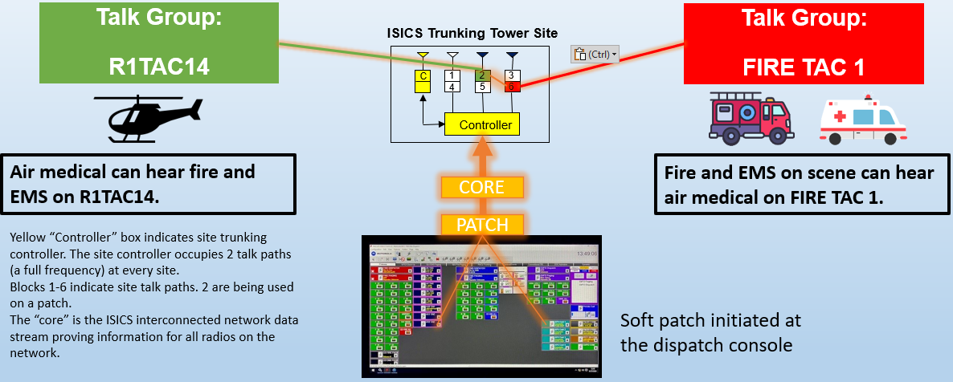

(This diagram shows a soft patch that was initiated at a dispatch console. In the diagram, talkgroup on R1TAC14 (timeslot 2) and Fire TAC 1 (timeslot 6) are patched in together.)

Hard Patches

A hard patch is “hard-wired.” This type of patch requires the use of physical gateway equipment with subscriber radios to complete a patch. These patches are used to patch between two different radio systems. These patches can also be used by a Communications Unit Technician (COMT) for emergency communications at the scene of an incident. The drawback of utilizing a hard patch is that the setup and configuration process can be time-consuming, requiring additional knowledge about the equipment involved.
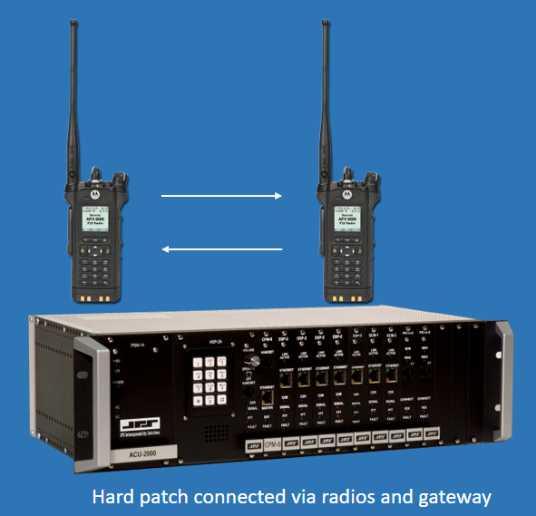

(This diagram shows a hard patch that was initiated at a gateway. In the diagram, two portable radios are connected to the gateway through a wired connection to be able to talk to one another.)

Two-Way Communication Patching
Patching

Resource Management with Patching

A crucial consideration when using a patch is the number of resources required to facilitate a single conversation. Instead of using a single channel/talkgroup, you are using two or more. This takes up an extra talkpath(s) on the trunking site. Sites are limited to a certain number of talkpaths.

Managing and maintaining patches can be complex, especially in large-scale or multi-agency operations. Operators need to ensure that all interconnected systems are properly configured and monitored to avoid misunderstandings or miscommunications.

Not all radio systems are technically compatible for patching. Different systems may use different modulation techniques, signaling formats, or frequencies that cannot easily be interconnected without special equipment or conversions.

Patches can introduce additional points of failure or degradation in audio quality. The quality of communication across patched systems may not always be as reliable as within a single system due to potential issues like latency, noise, or signal loss.

Patches can raise security concerns, particularly when linking sensitive or encrypted channels. Ensuring that patched communications maintain the necessary level of security and encryption protocols is crucial to prevent unauthorized access or interception.

Setting up and maintaining patching capabilities may require additional equipment, software, or training, which can incur costs. Organizations must weigh these costs against the benefits of improved communication flexibility.

Resources and StatusBoard

Dispatch and credentialed COMU personnel have access to the ISICSB StatusBoard. This is a web-based communications tool that allows agencies to see what channels/talkgroups are being used and which ones are available to be used at the regional and statewide levels. It is very important to utilize the StatusBoard before placing a patch to ensure the channel/talkgroup is open for use. ISICS StatusBoard training can be found on the the website https://isicsb.iowa.gov

Announcement of a Patch

It is considered best practice to always announce when a patch is created or taken down. This helps other users on the system know when a resource is being utilized and when it's available again for use.

Patching with Encryption

When patching encrypted channel(s)/talkgroup(s), it's important to be mindful that there's a chance the encrypted channel/talkgroup could lose its encryption, potentially allowing outsiders to listen in. If an agency operates with day-to-day encryption and patches to a
statewide or regional interoperability talkgroup that is not encrypted, the audio will be broadcast unencrypted. (See the last 3 talkgroups in each region in the ISICS talkgroup diagram; interoperability talkgroups followed by an “E”, designate an encrypted talkgroup).
Two-Way Communication Patching

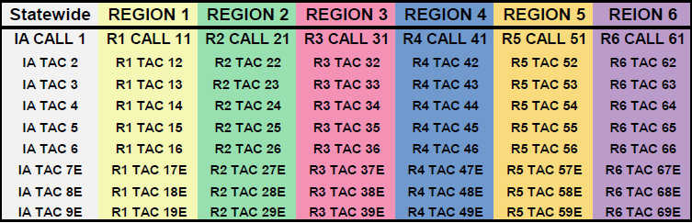

Local Policy and Procedure

Always make sure to refer to your agency's local operational policies and guidelines to ensure compliance. If you're unsure about anything, contact your immediate supervisor for clarification.
Conclusion

Patching two radio systems together requires careful planning, technical expertise, and adherence to standards and protocols to ensure reliable and secure communication. When implemented correctly, it significantly enhances interoperability and operational effectiveness in diverse and complex environments. Overall, while patching can enhance communication capabilities across disparate radio networks, it is important to carefully consider the limitations and plan accordingly to ensure effective and reliable communication in critical situations.

